**Sprint 3 Review**

Title: Summarize Everything

Team: Summarize Everything

Feb. 22, 2022

**Actions to stop doing**

* Committing directly to mainline branches. The team should stop doing this because it can lead to breakage on the mainline branches and difficulties when merging changes made to the same branch.

**Actions to start doing**

* Start writing unit tests/integration tests for code. This would be a good idea because this would check that the code behaves as expected.
* Check for code coverage and comment coverage. This would ensure that more of the code is tested and makes it easier to understand.
* Enforce frontend coding style guidelines and check using [./style.sh] before commits. This would make it easier to keep the code style consistent and improve maintainability of the codebase.

**Actions to keep doing**

* Keeping code styling consistent. This helps the team when editing code by making it easier to read and understand.
* Frequently committing. This keeps the team up to date with what team members have been working on.
* Keeping up with documentation. This makes it easier to create the documentation and makes creating documentation a useful process in the course of development.

**Work completed/not completed**

* *Completed*
  + URL parsing
  + Websockets implementation
  + Model prediction status indicators
  + Style guide (python)
  + Model evaluation
  + Non-mix models
* *Not Completed*
  + Unit tests
  + Style guide (js)

**Work completion rate**

* # of completed User Stories: 4 **of 4**
* Estimated work hours from sprint: 50 **hr**
* # of days in sprint: **14**

**Completed burnup chart**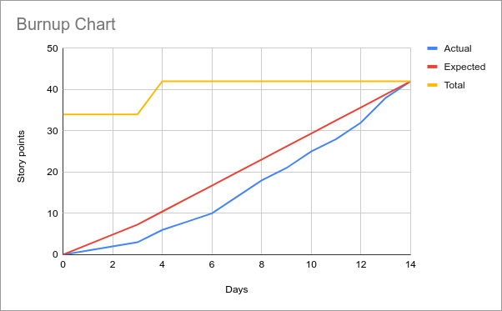

**Completed Scrum Board**

